|  |
| --- |
| Circle Language Spec: System Objects |

## System Interface of a Related Item

When you open up the system interface for a Related Item, you get to see the system commands that apply to Related Items. Aspects, that apply to a Related Item are:

- Reference

- Object

- Existance

- Class

- Name

### The Reference Aspect in the System Interface

The Reference aspect is controlled through only one command:

Reference Get

The Reference aspect is placed inside a triangle, that wraps together the members to control the Reference aspect:

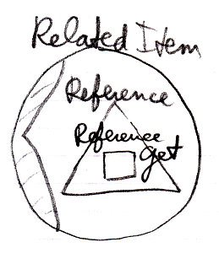

### The Object Aspect in the System Interface

The Object aspect of a Related Item is controlled through several commands:

Object Get

Object Set

Use Reference As Object

The commands are placed inside a triangle, that wraps together the members of the Object aspect:

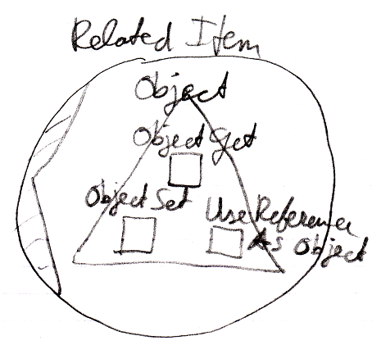

### The Existence Aspect in the System Interface

The Existence aspect is controlled through two commands and an attribute:

New

Annul

Is Something

The members are placed inside a triangle, that wraps together the members of the Existence aspect:

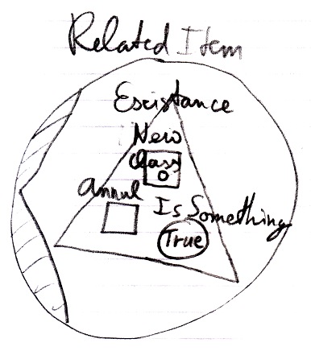

### The Reference-Class Aspect in the System Interface

The Class aspect has *five* system commands, but only *three* of them apply to Related Items:

Class Set

Reference-Class Get

Use Reference As Class

The commands are placed inside a triangle, that wraps together the members of the Class aspect:

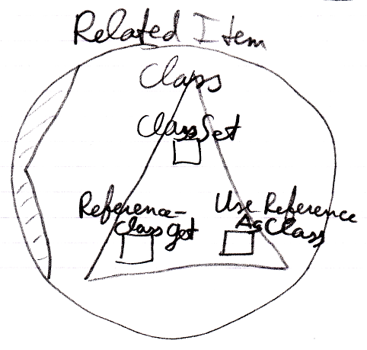

### The Name Aspect in the System Interface

The Name aspect is controlled through two commands:

Name Get

Name Set

The commands are placed inside a triangle, that wraps together the members of the Name aspect:

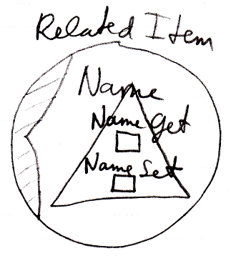

### The Full System Interface for Related Item

The full system interface of a Related Item looks like this:

